Contacts Manager

The simple, powerful, and easy way

to manage your contacts

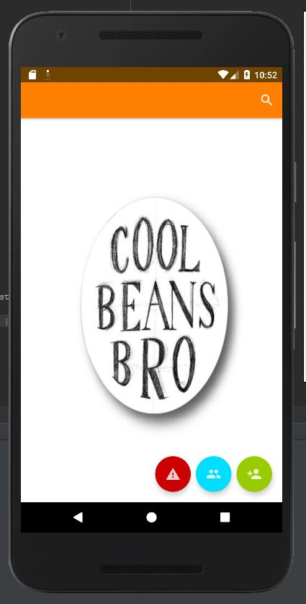

Yeswanth Bogireddy

Ahmed Khan

Mukund Kuntimad

Raj Tailor

Downloading and Running the Project

Step 1: Open Android Studio



Click on “Check out project from Version Control” and select Git

Step 2: Paste repository link into the URL text box and choose a directory.

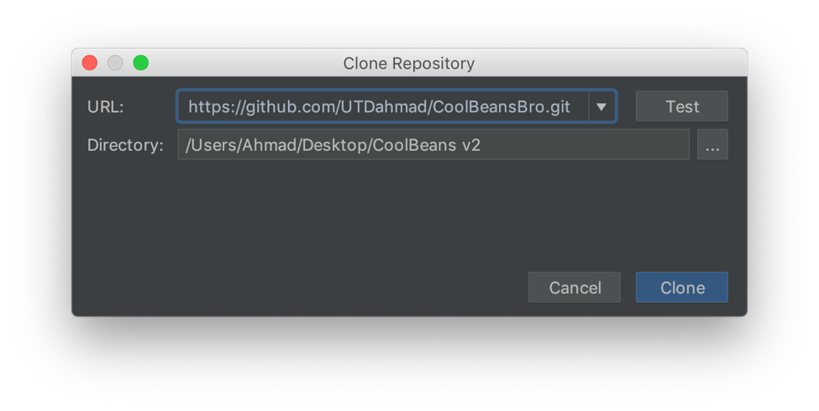

Click Clone

Step 3: Click “Next” on the following pages:





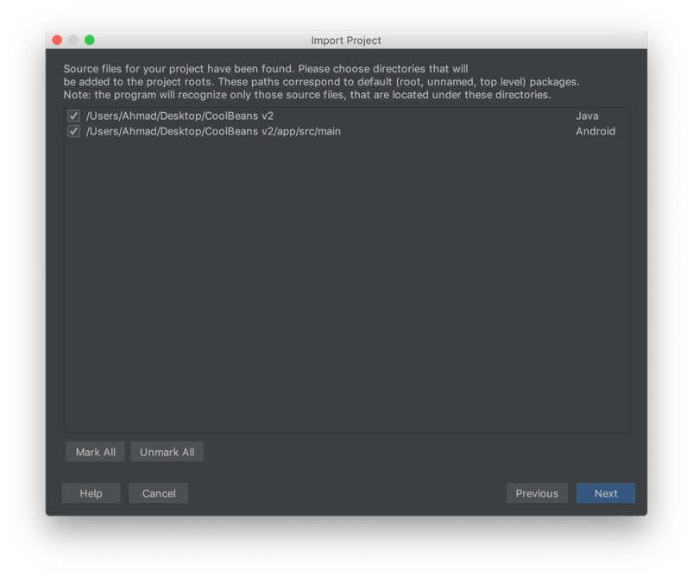



Step 4: Select Android API 28 Platform and click “Next”

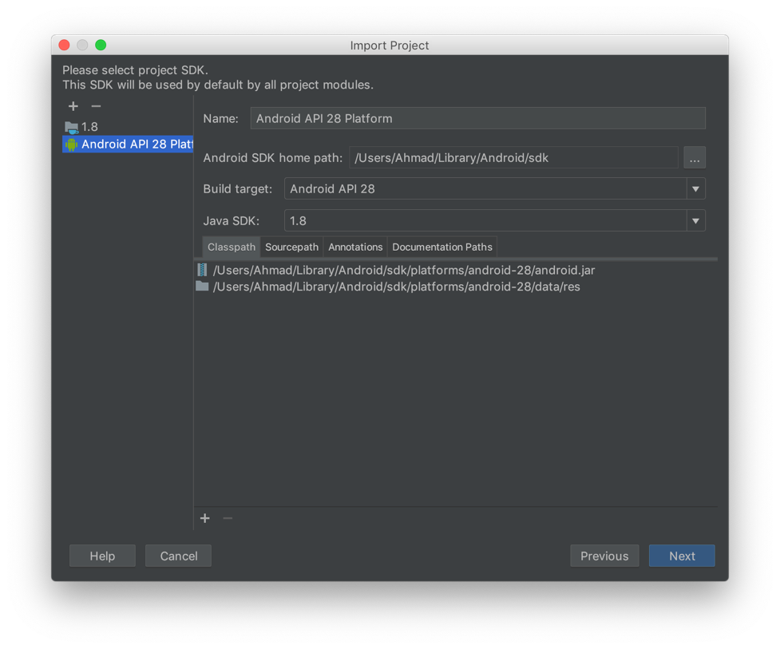

Step 5: Click “Finish” on the following screen:



You should now be on the following screen:

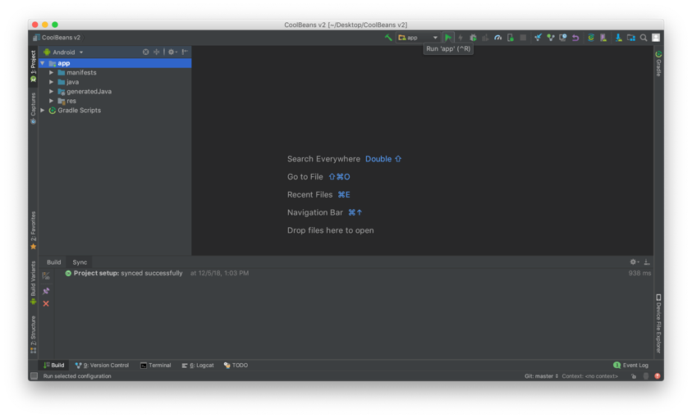

Step 6: Click the green Run button.

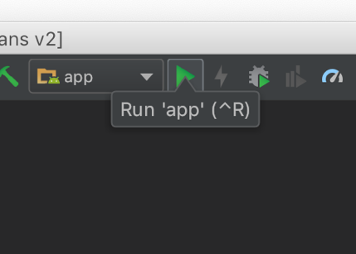

Step 7: Select a device. (For our testing purposes, we used a Pixel 2 virtual device)



Step 8: Press cancel on the following screen (if it pops up):



Step 9: You are now ready to use the app. Please see the “Setting Up for Full Functionality” section to see how to enable location services for the application.



Setting Up for Full Functionality

***Important: Please follow steps to enable Location Services for the contacts manager app.***

Step 1: Open the settings app on the device.



Step 2: Use the search bar to search for and select Location Services



Step 3: Select App-Level permissions



Step 4: Turn on the toggle to allow the app to access location data.



Implemented Functionality

1: The main screen



On the main screen, you will find three floating action buttons, one search button, and a ListView item. The three floating action buttons at the bottom right of the screen allow you access the emergency call feature, the groups feature, and the add contact feature. On the top right, you will find a search button that will reveal a search bar.

2: Searching for a contact



Clicking the search button on the top right of the main screen will expand the search view, and a keyboard pops up onto the screen. Notice how the floating action buttons remain accessible and are still clickable at this moment.

3. Entering a new contact’s information



When the green button with the new contact icon is pressed from the main screen, the user is taken to this screen where contact information can be filled in.



When one of the input fields is clicked, all of the boxes shrink in height to fit on the screen above the keyboard. This feature was added so the user can skip to any input field at any given time.



Notice how the keyboards change based

on the input field

4. Accessing Emergency Contact information



In the event of an emergency, every second matters. If you’re visiting a different country, you may not know the local emergency numbers. This app accesses the phone’s location to provide the correct emergency number in 11 different countries whose combined population is over 1.6 billion people. More countries are to be added later.

This screen presents the country name in a small font size and puts the emergency contact number (the important information) in large font. The red make emergency call button would theoretically make a call to the desired emergency number, but has been left “disconnected” while the app is still in its testing phase.

Testing

Junit Test 1 Class: *app/src/test/java/com/coolbeansbro/contactsmanager/EmergencyCallActivityTest.java*



This Junit test class tests the returnEmergencyNumber function.

It tests with correct countries that are supported, a string that does not correspond to a supported country, and an empty string.

Testing

Junit Test 2 Class

*app/src/test/java/com/coolbeansbro/contactsmanager/AddContactActivityTest.java*

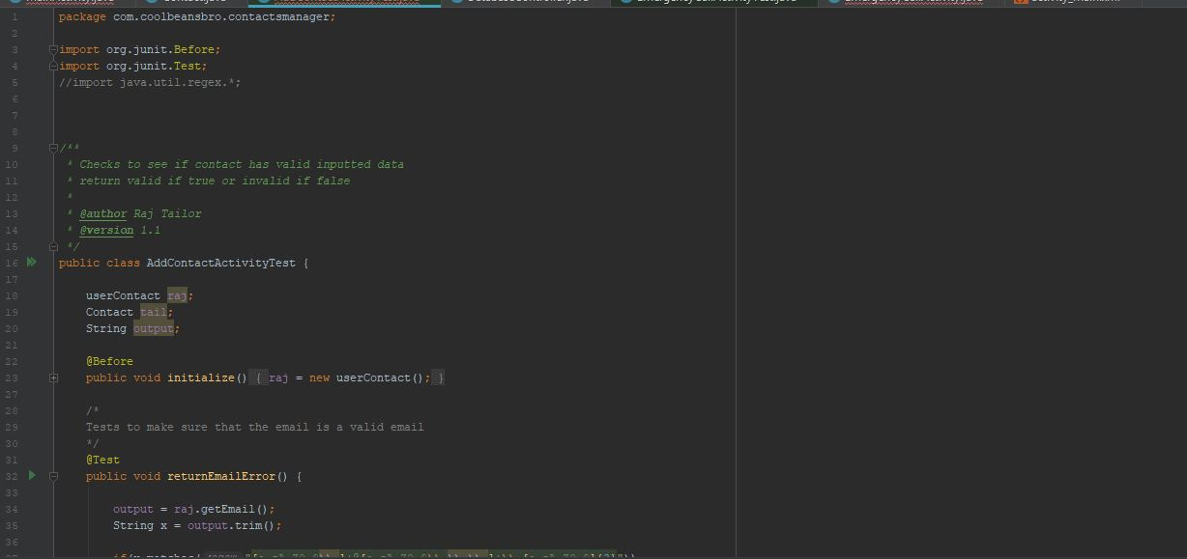

This Junit test class tests the getEmail and getAlternateNumber function.

Testing

Junit Test 3 Class:

Testing

Junit Test 4 Class:

Refactoring

Extract Method: app/src/main/java/com.coolbeansbro/contactsmanager/EmergencyCallActivity

*Original Code*



*Refactored Code*

We took a large chunk of code and moved it into its own function in order to make the original function shorter and increase the readability of our code.

Template Method Pattern

Location: app/src/main/java/com.coolbeansbro/contactsmanager/Contact.java



Each subclass is similar, but does things a little differently. We used the template method to let the subclasses redefine certain functions of the “template” contact class.